**Start Talking Maryland Third Grade Lesson: Family Take Home Activity**

Today, in your child’s class, we discussed prescription and non-prescription drugs. Please talk with your child about what he/she learned about drug safety.

You may want to review this picture of an over-the-counter medication bottle label with your child:

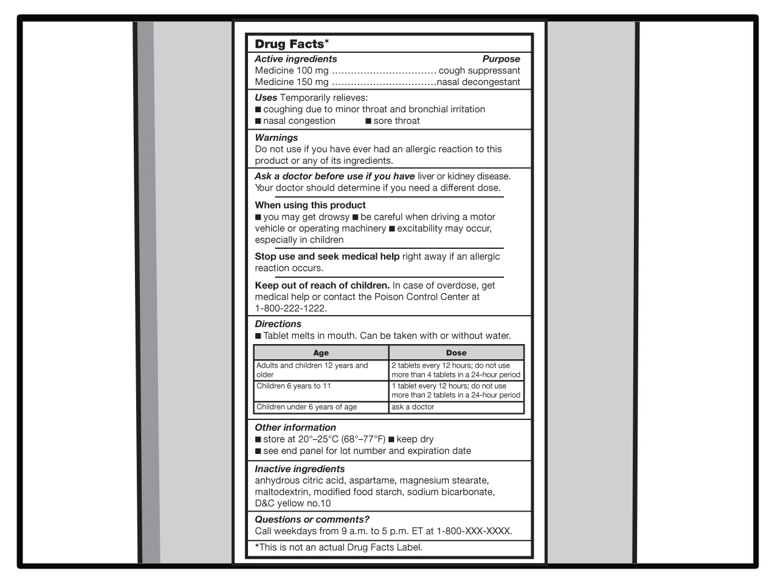

These are some of the things your child learned today:

* The difference between prescription and non-prescription drugs
* The importance of following directions when taking any medication
* Ways to take medication safely

|  |  |
| --- | --- |
| Non-Prescription Drugs | Prescription Drugs |
| You can get at a drug store without a prescription.  A parent reads the instruction label to give you the exact amount for your age and weight.  It is regulated by the Food and Drug Administration.  Always follow the warning label, keep away from children.  **Names of nonprescription drugs.**  Tylenol  Ibuprophen | Your doctor prescribes the medication for a specific reason and person.  A parent or responsible adult gives you the medication. The parent reads the doctors’ orders on medication and gives you what is stated on the medication bottle.  Prescriptions come with information from pharmacists about warnings such as “take with food” or “possible side effects to contact doctor”.  Drug prescriptions are regulated by the Food and Drug Administration.  Prescription drugs are only for the person they are prescribed for and not for anyone else.  **Names of some prescription drugs.**  Amoxicillin    Ritalin  Fentanyl |