# Richard Henry Lee Elementary

SOARING TO EXCELLENCE: MONDAY, AUGUST 28, 2023

**August 2023:**

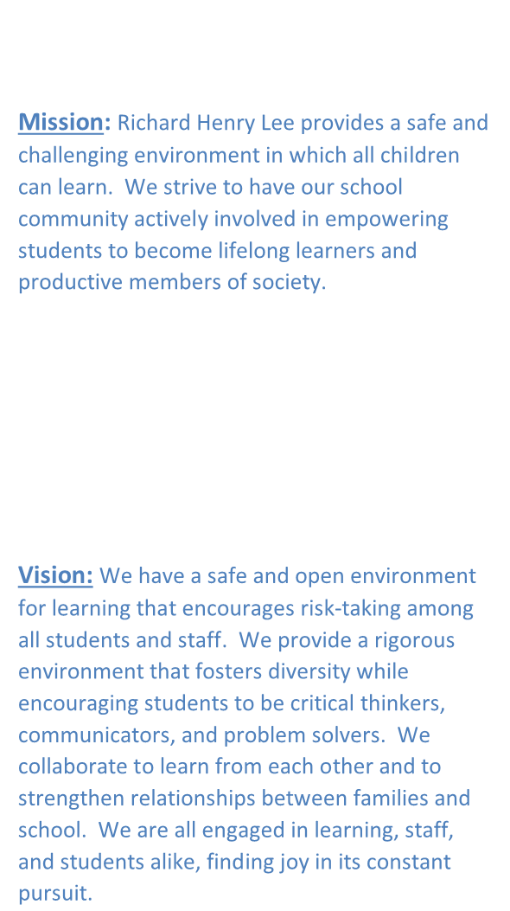

**Mission:** Richard Henry Lee provides a safe and challenging environment in which all children can learn. We strive to have our school community actively involved in empowering students to become lifelong learners and productive members of society.

**Vision:** We have a safe and open environment for learning that encourages risk-taking among all students and staff. We provide a rigorous environment that fosters diversity while encouraging students to be critical thinkers, communicators, and problem solvers. We collaborate to learn from each other and to strengthen relationships between families and school. We are all engaged in learning, staff, and students alike, finding joy in its constant pursuit.

|  |  |
| --- | --- |
| **28th** | **First Day of School for Grades 1-5 Only** |
| **28th- 29th** | **Kindergarten Conferences** |
| **30th- 31st** | **Staggered Entrance Days for Kindergarten** |

**September 2023:**

|  |  |
| --- | --- |
| **1st** | **Staggered Entrance Day For Kindergarten** |
| **4th** | **All Schools and Central**  **Offices Closed – Labor Day** |
| **5th** | **First Day of School for All Kindergartners** |
| **7th** | **Back-to-School Night and PTA Meeting**  **5:30 PM – 7:00 PM** |
| **11th- 14th** | **Fifth Grade Water Ready Classes** |
| **25th** | **All Schools and Central Offices Closed – Yom Kippur** |

**2023-2024 School Calendar**

[https://www.aacps.org/site/handlers/filedownload.ashx?moduleinstanceid=36335&d](https://www.aacps.org/site/handlers/filedownload.ashx?moduleinstanceid=36335&dataid=94619&FileName=-2324adoptedcalendar.pdf) [ataid=94619&FileName=-2324adoptedcalendar.pdf](https://www.aacps.org/site/handlers/filedownload.ashx?moduleinstanceid=36335&dataid=94619&FileName=-2324adoptedcalendar.pdf)

Dear Families,

Welcome to the start of the 2023-2024 school year! We are so excited to begin a new school year with your children! Our teachers are eager to meet all of you at Back to School Night on September 7th. On this night we will have a Title I overview and PTA meeting at 5:30 PM in the cafeteria, and our first session with teachers will begin at 6 PM. We hope you can attend and learn about what your child will be learning this school year.

Our number one priority is always the safety of your children, and ensuring they are learning in a fun, welcoming environment. We know that students learn best from teachers they love. Positive relationships between teachers and students are so important to academic success. Your child’s smile and laughter brighten our days, and we can’t wait to be teaching them every day.

Our academic goals for the school year are focused on

Reading and Mathematics. In Math, we will have a new curriculum, called “Reveal”, which you will learn about at Back to School Night. We are focused on ensuring that all our students are fluent in computation standards. In Reading, our goals are centered on ensuring that all students grow in the areas of fluency and comprehension. We strive to foster a love of reading with all students.

Please remember that instruction for the school day begins at 8 AM. Our doors open at 7:40 AM. It is so important that your child arrives on time daily, ready to learn.

We appreciate you being a partner with us as we work together to help your child succeed in school. We are going to have an amazing year together!

Respectfully,

Ms. Koennel, Principal

# School Counselor’s Corner

### A person wearing glasses Description automatically generated with low confidenceHello Parents/Guardians! My name is Mrs. Horn. I am the School Counselor at Richard Henry Lee Elementary School. I am extremely excited about the new school year! I will be meeting with your child’s class throughout the year, providing classroom guidance lessons on varying topics, including personal safety, career exploration, organization, etc.

In addition to classroom guidance lessons, I also am available to meet with children individually and in groups, as needed, to discuss any academic or personal/social issues that might arise throughout the school year. I am a resource for the students, but for parents as well, so please feel free to contact me with any questions or concerns. I look forward to working with you and your student at Richard Henry Lee Elementary School!

**Sharing Circles**

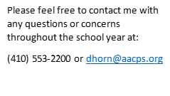

### A picture containing bubble chart Description automatically generatedRHLee will continue to work with students to build community and cohesiveness within our classrooms and school-wide this year with the use of our “Sharing Circles”. Teachers will be facilitating sharing circles in each classroom. These circles will provide students with the opportunity to learn more about their classmates and teachers throughout the school year. We’re excited about how sharing circles are helping to foster a positive school culture here at RHLee!



**Back to School Program**

Through the generosity of community organizations, our Back-to-School Program was able to provide 69 backpacks filled to the brim with supplies to help students in need succeed this school year! We also want to thank the numerous community organizations who helped to provide school supplies to our school! Your generosity is greatly appreciated.

**School Attendance Matters**

In Kindergarten and First grades, 1 in 4 students are chronically absent. Did you know that chronic absenteeism in Kindergarten can negatively impact reading proficiency by the end of 3rd grade? (<https://www.attendanceworks.org/>)

### It is important for your child to come to school every day. If they miss school because they are sick, please let their teacher know. Any student who is absent three or more days will need a doctor’s excuse to return to school.

We want our students at RHLee to come to school, achieve academic success, and have a lot of fun while doing so!



**Food and Nutrition** [**https://aacpsschools.org/nutrition/**](https://aacpsschools.org/nutrition/)

[**APPLY FOR FREE/REDUCED PRICE MEALS HERE**](https://applyformeals.aacps.org/)

**All students may apply to receive free or reduced-price meals at AACPS.**

**Previously, a paper application was sent home on the first day of school to all students and online applications were accepted. The online process has proven to be faster and more accurate, is available in English and Spanish, and can be completed on a computer or smartphone.**

**We will continue to provide paper applications for parents without access to smart phones/computers. Please note that the amount of paper applications is limited.**

**Instructions To Apply for Free or Reduced-Price Meals**

**Apply online any time during the school year after August 1, 2023.**

* **All information is confidential.**
* **Once the online application is submitted and validated, the eligibility status of your child(ren) will be sent home.**
* **Online meal benefit applications are fast, easy, and determined within a few days.**

*School Meal Prices SY 2023-2024*

*Student:*

*Breakfast, (Full Price, All Schools) $1.50*

*Breakfast, (Reduced Price, All Schools) $ .00*

*Lunch, (Full Price, Elementary Schools) $2.75*

*Lunch, (Reduced-Price, All Schools) $ .00*

*If you have any questions regarding the school meals program, please email* [*jrisse@aacps.org*](mailto:jrisse@aacps.org) *or call 410-222-5900.*

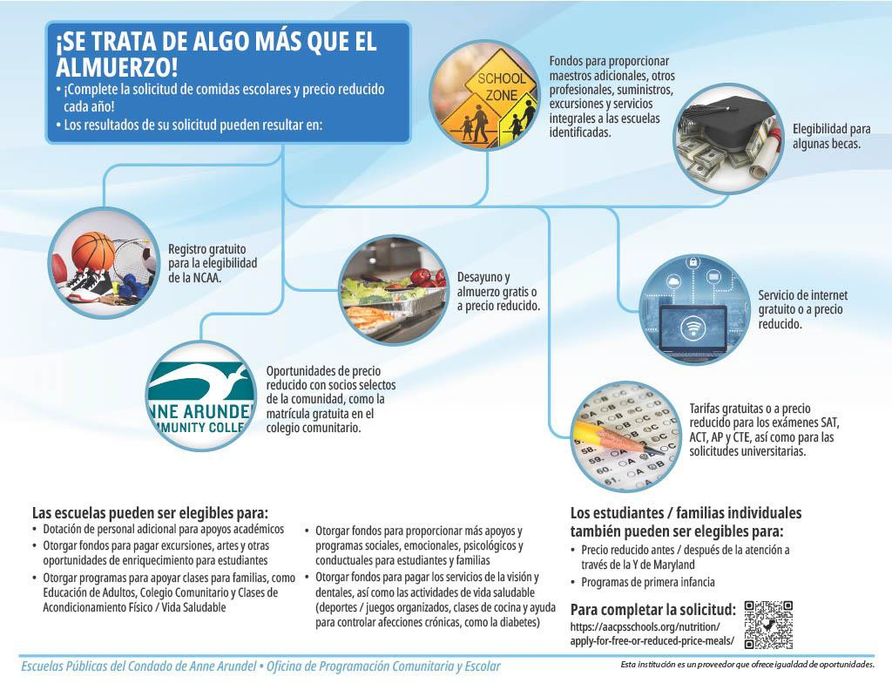

RHLEE Lunch Schedules

|  |  |
| --- | --- |
| Kindergarten | 10:20 AM - 10:45 AM  9:50 AM – 10:15 AM (Early Dismissal) |
| 3rd Grade | 10:50 AM - 11:15 AM  10:15 AM – 10:35 AM (Early Dismissal) |
| 2nd Grade | 11:20 AM - 11:45 AM  10:35 AM – 11:00 AM (Early Dismissal) |
| 1st Grade | 11:50 AM – 12:15 PM  11:00 AM – 11:25 AM (Early Dismissal) |
| 4th Grade | 12:20 PM – 12:45 PM  11:25 AM – 11:50 AM (Early Dismissal) |
| 5th Grade | 12:50 PM – 1:15 PM  11:50 AM – 12:15 PM (Early Dismissal) |







|  |  |  |
| --- | --- | --- |
| Health Assistant: | Eva Ramos | 7:45 AM – 2:45 PM |
| Nurse: | Katie Houston | 7:30 AM – 4:00 PM |

Parents: Please provide a season appropriate change of clothing for your student.

**CELL PHONE USE**

While we recognize that many students use personal cell phones to maintain communication with parents after school, it is vital that cell phone use does not interfere with instruction during the school day; therefore, use of cell phones or other personal electronic devices during the school day is strictly prohibited.

All electronic devices must be turned off and kept in the student’s backpack or locker until they have exited the building at dismissal, unless special arrangements have been made with their teacher.

Any electronic device being used without permission during the school day will be confiscated by the teacher and returned at the end of the day.





Welcome back to all our Richard Henry Lee Eagles. The 2023-2024 school year is going to be amazing. The Literacy Teachers, Mrs.

Drenning, Mrs. Miller, and Mrs. Holden are excited about a year of reading and writing! Throughout the school year, there will be opportunities for students to participate in reading incentives at home, evening events for both parents and students, and daily reading and writing in the classroom setting. We look forward to seeing our Eagles soar this year!

***Reminder- if your child participated in the Anne Arundel County Public Library Summer Reading Program, please bring their completed form to school, and give it to their classroom***

***teacher. Those students who turn in their form by Tuesday, September 5th will receive a special prize.***

## Bus Information

The link below is the 2023-2024 bus stops for Richard Henry Lee Elementary <https://busstops.aacps.org/Details.aspx?school=1242>



Visit <https://www.aacps.org/locateyourschool> to find your child’s school

and determine their eligibility for bus transportation.

To contact the Transportation Division, call 410-923-7890 or email [transportation@aacps.org](mailto:transportation@aacps.org)

## Registrations/Enrollments

**Kindergarten Enrollment Link below**

[**https://secure.aacps.org/webapps/SEFP/en-**](https://secure.aacps.org/webapps/SEFP/en-US/OSS/Enrollment/Form?gradeLevel=Kindergarten)[**US/OSS/Enrollment/Form?gradeLevel=Kindergarten**](https://secure.aacps.org/webapps/SEFP/en-US/OSS/Enrollment/Form?gradeLevel=Kindergarten)



## Grade 1-5 Enrollment link below

[**https://secure.aacps.org/webapps/SEFP/en-**](https://secure.aacps.org/webapps/SEFP/en-US/OSS/Enrollment/Form?gradeLevel=General)[**US/OSS/Enrollment/Form?gradeLevel=General**](https://secure.aacps.org/webapps/SEFP/en-US/OSS/Enrollment/Form?gradeLevel=General)

### Escuelas P1Cibncas del Condado d,e Anne Arundel Ofiicina Princi1pal de Operacion&s

**Depiartamento** d,& Trans1portes

**Actualizacion: c,ORDONES y PASAMANOS** DEL **AUTOBUS**

#### IEI problema:

Los cordoliles de la ropa de los nii'ios se quedan enganchados ,en bs pasamanos del autoblJs esoolar ubicados ,elil r:a.,eliltrad,a del a11tob1Js escor:ar. AJrededor de media dooena de j,6venes en todo el pars han muerto y mas han sufrido,l,esi,ones graves 01Jalildo ros cordones se ,emedan en el pa.samanos del autobus ,escolar. El probr,ema ocur1re c1Jalildo I.a lolilgitud del cordon permite que el lilii'io baje al suer,o y se ubique en un area fuera de la vista del conductor del .autoMs esoolar. Cuando,el autoMs sale del rea de la parada mieliltras ,el cord6n est.a bloqueado,haoe que el j,oven sea arrastrado por el costado o debajo del autobus esool.ar.

#### IRemedilos:

1. **. lnspeooionar y mod1ificar los aooeso:rios de las juntas de los pasamanos:**

Los pasamanos de rns autobuses ,escolares han sldo·nspeooi,onados en todas la.s inspeociones peri6dicas r,ealizadas d,esde el verano de 1995. La.s futura.s inspeoor,ones de autobuses ,esoolares contlilil1Jaran incluyendo,una revisi,6n de este problerna.

Los pasamanos q11e pueden causar un problema han sido,modirfr,cados, reemplazados y, donde esta permitido, ,el'iminados. E:n la mayorra de los casos, el remedio aumenta el espaar,o ,en la parte infer1r,or de I.a junta donde el pasamanos se une a la entrada del autobus escor:al".

#### . lnstrucciones a los conducto11es de .autobus,es

Todos las ,001"1d1Jctor,es de autobuses esoolar,es han sido,il'lformados de ,este asunto y han r,ecibido,r:a.s instlruool,ones apropiadas. Se ha instlruido,a los conduotores para que se aseguren de que las pa.sajeros recientemente descargados h,ayan salido de I.a '"z.ona de peligro,'; del autob s escolar antes de dejar m1a parada de autobus o IJl'l,a zona de descarga escor:al".

#### . La fumcUiln de los padr,e.s:

Se alienta a las padres a ,examinar l,os comones de la ropa q11e ya ti,enen. Todos los cordones, y.a sea a.l'li1vel del cuello,, la dntura o r,os rnuslos, ti,enen riesgo,. Los ,ooroones qm;, tienen botones .al final del oord6n solil partkularmente peligrosos. T,emga en cuenta este problema ouando,oompre ropa nueva. La Administraoi,6n Nadolilal de Segm1idad del Tratioo en las Carireteras (NHTSA, par sus si,glas en ingr, s) sugieire que se corten o,qu1ten bs cordones.

T,enga en cuenta que las probr,ema.s con las cordoliles nose limitalil a. r,os pasamanos debs autobuses ,esoolares Se pueden experimentar prob!,emas adidolilar,es en equipami,entos de juegos de reareo,, bidcletas, ,escaleras mec lil1cas, equipo.s de a.11tom6viles, j11egos mecani,oos y casi cualquier oosa q11e 111111eva a las persolilas.



IPARA PADRESfTUTO:RES LIEGALIES DE

ESTLIIDIANTiES DE LAS ESCUIELAS IPUBLIICAS IDEL CONIDA!DO DE A!NIINIIE ARU NDEIL

SIEGURO VOLUINITARIO IDE ACCIDEINITES IPARA ESTUDIAN11ES

Cada ai'lo los escobres tieanen accidentes. Los costos RIBdioos pueden ser caros y las facturas i.nesperadas pueden causar dificultades. fodus.o si tiene otro seguro a menudo no es sufidente. a que la cobe-'flttl.ra p,u.ed req11erir deducible altos o pagos de co egmo.

Las cuelas Po.blicas de!l. Conda.do de Ann.e Arundel !!! oompran pMizas oolectivas de segmo RIBdioo ni dental para los estu.diantes q11e partidpan en activida&es deporti a en activida&es patrocinadas por la escu.ela o en actMdades esrudianlile.s mientras la esc11ela esra en funcionamiento. o obstante AACPS ha negocia<lo con *.'Bob McCJtHkeJ1lnsnrance* para qu.e se ofre:z.ca una poliza de cobermra por acddeante a precio m6dioo a todos lo e.stu.dliante.s i.nscritos. Mediante es.te programa, los padres/tutore legate teandran la opommidad de adquirir es.t seguro para sus estu.diante.s.

s.tas son algunas de las ventajas de est segu.ro:

*'ohi!rt11.ro di! trCiddentt!s para l!Slt1dia1Jtl!Sen Ja t!sc.m!.la:* SJto proporcioma seguro para las hora.s y los dias e.n q11e la escu. la es.ta en fundonamiento y mieru:ras los es.tudiantes a isten a ar-tividades pa1rocinadas y supervi atlas por la es;cuela dentro o fuern de las insralacione.s de la es;c11ela. Se proporciona cobermra durante:

* Lajomada esco1ar, en las i.ns.taiadones de la e cuela, mientras la e cuela eslli en fundonamiento.
* De.splazamiento directo e ininterrum:pido des&e *y* hacia casa *y* dases programadas.
* Depo:rt.e.s patrocinados *y* wpervi <los por la e.sruela exduyendo el fililiol americano de la escl!lela ecunuria).
* l desp1azamiento hacia . desde deportcs patrocinados *y* supervisados por la esCl!lela en vebiculos ap.robados por la escue!l.a.
* na e:z qu **entra** en vigenda la cobertllra coru:inoa hasra la focha anterior et1 **qu** la oobeat1illra dei es.tudiante i.1111crito haya estado etll vinencia dooe m.e.s o el primer dla de!l. _pr6ximo ailo e.soolar.

*La. 24 lrnras del dla* - *obe.rtflm. di! Ciddi!ntl!S14 ho.ras:* E-sto proporciona cobertura de seguro las 24 horas, en cuaiquier part.e del mundo. Se p.roporciona cobertura:

* + Antes, dura!llte *y* despue.s de la escu.ela..
  + ines de semana, vacaciones *y* todo el verano (queda ex.cluido el flitbo1americano de la e.scuela secundaria).
  + Depo:rt.e.s patrocinados por la es.cnela depo:rtes extracurriculares ql!leda ex.duido el filmol am.ericano de la e.scuela s;ecundaria _
* na e:z qu entra en vigenda la coberrura coru:inoa hasra la fecha anterior cuando la cobertura dei estudiante i.1111crito haya estado vigente dllrante doce Mere o el primer dia del p.roxilno ano escolar.

*Toda la cobenura enrru en vigf!1!cia en la*- *eclnl en que la .wlicl!lid'd'eh/dame11rt! conrpletada y la prln a* . oo *r:ecih/das por Bob Mc.Cl,,skeyiln.mrance. o c11011do se ln1 rompletad'o la inscripcirm en line-11.*

P DE RE• LlZ . R L . SOLICIT PAGA.It K L E• Ii'. : wv,•w.bobmcdoskey.com/K.12Voluntm:y *y*

bacer ciic en e!l. boton "inscripci6n e.n linea *(Enroll Onli11e).* Ti.ene la opci6n de diforentes p.rogramas de beneticio .

Si tiene preguntas, no dude en llamar a *.'Bob M-c.Closkt!p* hJi'fl.lWJCie. a1 800) 445 3126. Sus repre entantes enc11entran dispooibles para asistirle oon sus preguntas,.o isite ww·w.bobmccloskey.oom/Kl2Voluntary.