Dear Families and Friends:

Welcome to Ridgeway Elementary School! We are glad to have your family with us.

Children succeed and thrive in an environment that provides rigorous, challenging experiences in a supportive atmosphere. The faculty and staff of Ridgeway are committed to helping each child maximize his/her potential.

Education is most effective when the school and family work together. We invite you to take an active role in your child’s education by joining the PTA, becoming a parent volunteer and by always maintaining close communication with your child’s teachers.

School newsletters and notices will be posted on the school website and sent home with the children when requested. Please check the website monthly for these important updates and encourage your child to be responsible for seeing that you receive all paper communications.

This handbook is designed to familiarize you with our school and to answer questions about school policies and procedures. Please read it and keep it as a reference. It is a supplement to the Anne Arundel County Public Schools *“Parent Handbook.”*

We look forward to working together with you and your children as we strive for academic success for all students!

Sincerely,

Janet Lancaster

Janet Lancaster

Principal

***Show Your Ridgeway Pride***

***I am a Marvelous Mustang.***

***Every day, in every way, I show GRIT by:***

***Growing and Succeeding.***

***Respecting our community.***

***In charge of my words and actions.***

***Teaching and building relationships with others.***

***Mustang Tough: I have GRIT!***

#### **School Hours**

Ridgeway’s school hours are from 8:00 a.m. until 2:25 p.m. Buses start unloading at 7:45 a.m. and all buses have usually left the school grounds to take children home by 2:40 p.m.

Walkers and children being driven to school should arrive between 7:45 a.m. and 8:00 a.m. **Students must not be left at school early (before 7:45)**. **All students must be in their classrooms at 8:00,** so as not to be marked tardy. **Students who arrive after 8:00 must be brought into the school office by an adult to be signed in and receive a pass to enter class.**

Children are permitted to ride bikes to school. All bicycles are to be parked in the bike rack and locks are strongly recommended. Bicycles must be walked on school sidewalks.

Dismissal begins at 2:25. School Age Child Care is dismissed first, followed by bus riders, car riders/daycare vans and walkers. No student should cross the driveway without supervision, walk between cars or buses, or leave the sidewalk for any reason. After students leave the building, they may not re-enter without permission of a duty teacher. Students released as walkers may not stay on the playground or fields after school.

#### **Daily Schedule**

7:40-8:00 Breakfast

7:45 Morning Bell - Student Arrival

8:00 Morning Announcements

8:10 Instruction Begins

10:15- Lunch Shifts

1:40 by grade level

2:25 Dismissal

#### **Early Dismissal**

When a student is to be dismissed early, the school should be notified in writing in advance of the early departure. The note should contain the date and time of the early departure and the name of the person who will be picking up the child from school. The child must be picked up from the office at the appointed time and signed out at that time by the person who will be responsible for the child. Please be prepared with picture identification. In order to help ensure a safe and orderly departure from school for all students, early dismissals must be done prior to 2:00; otherwise, the regular dismissal procedure will need to be followed.

If you need to pick up your child, please report to the office. We will send for your child and you will be asked to sign him/her out. Parents, guardians, and those listed on your Student Emergency Information Form are the only individuals allowed to pick up a student from school. You must send a written permission for dismissal to other individuals.

#### **Attendance**

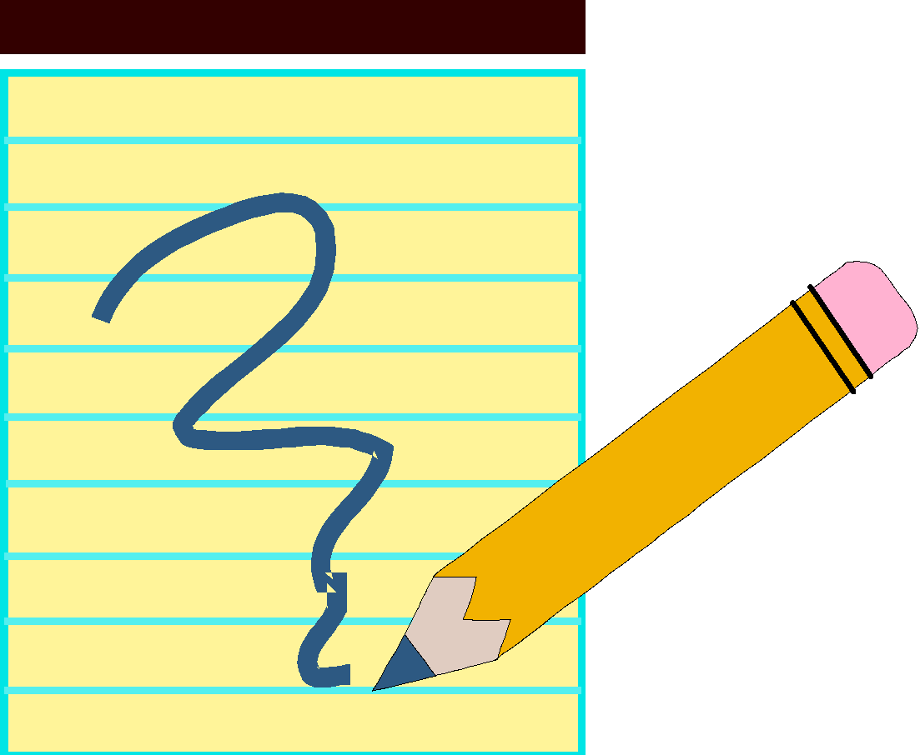

Regular school attendance is very important to your child’s academic progress and success in school. Please try to schedule dental/medical appointments and other commitments for after school hours whenever possible.

When your child is absent, we are required to record a reason for the absence. Please have your child bring a note from you when he/she returns. The note should state the reason for the absence. **If we do not receive a written reason for an absence, we are required to record the absence as illegal.** A child is legally absent when ill, when there is a death in the family or when another serious situation exists. If your child is absent in excess of five consecutive days, he/she must have a **doctor’s certificate** before returning to class. Children who have excused absences will be given time to make up work. Vacations are **not** excused absences. We do not give out assignments in advance for anticipated vacation absences. In addition, according to Board Regulation JB-RA, the principal may require a physician’s certificate from the parent(s) of a student with a pattern of excessive absences. Excessively absent refers to a student who is absent six or more days a semester.

#### **Breakfast Program**

#### 

Breakfast is available in the school cafeteria each morning. Breakfast cost is $1.50 and there is no cost for students qualifying for the reduced priced program.

#### **Lunch Program**

Lunches may be purchased at school for $2.75 full price and there is no cost for students qualifying for the reduced price program. You may pay for lunches in advance and use them as you like. This is encouraged as it avoids “lost” or “forgotten” monies. Checks/cash (payable to Ridgeway Cafeteria) will be accepted in the school’s cafeteria or MealpayPlus offers you a convenient, easy, and secure way to make prepayments using your bank account or your Visa or MasterCard. Visit mealpayplus.com for more information and registration.

Snacks, i.e., cookies, brownies, ice cream, may be purchased during lunch. A form, signed by the parent, will be required before allowing a student to purchase snacks using his/her prepaid lunch account.

Application forms for free or reduced lunches will be sent home at the beginning of the school year. Families may qualify according to the federal income eligibility guidelines. All applications are kept confidential and are accepted at anytime during the school year.

Students are expected to use good manners and courteous behavior in the cafeteria. Due to food allergies, and the need to respect parental dietary preferences, please remind your child that sharing and/or trading food with classmates is **not** acceptable. Due to space limitations and the safety and supervision of our students, we are not able to accommodate guests during lunch.

**Birthday Treats**

For the safety and comfort of all of our students, no food treats will be distributed to classmates for birthday celebrations. If you would like to recognize your child’s birthday at school, stickers, pencils or erasers are preferred. Many of our students have dietary restrictions, food sensitivities and serious allergies. Thank you in advance for your adherence to this important safety policy. We love helping our students celebrate their birthday, however we do not distribute invitations for birthday parties. We also cannot accept gifts, flowers, balloons, etc. for students during the school day. 

##### **Immunizations**

The State of Maryland Immunization Regulation requires students enrolled in school to show proof of immunizations.

A student whose immunizations are not up to date or who has not provided proof of having received required immunizations will not be permitted to attend school until proper documentation has been provided to the school.

Children enrolled must show proof of 4 DTaP, 3 Polio, 3 Hepatitis B, 2 Measles, 2 Mumps, 2 Rubella (often given as an MMR) and 2 Varicella (Chickenpox).

#### **Health Care**

The school policy is to call parents when children are sick or hurt at school. Children who are too ill to return to class must be taken home by their parents. They may not remain in school. Children should not be sent to school to report to the office for treatment of wounds or illnesses that occur at home.

In the event that your child has an accident while in school, we will do our best to contact you. If we cannot contact you, we will take all appropriate measures to assure the proper treatment of your child.

Recess and play periods, either general or by class, are arranged during the day when weather permits. Students will not be exposed needlessly to bad weather. When a general recess is called, everyone is expected to go out. It is difficult to arrange alternate supervision for students.

Please be sure the school is aware of any particular medical situations that would affect the health or safety of your child (bee stings, allergies, asthma, etc.). Be sure this is indicated on the Emergency Card Verification form.

#### **Medication**

NO MEDICATIONS OF ANY KIND CAN BE ADMINISTERED BY THE SCHOOL STAFF UNLESS YOUR DOCTOR HAS FILLED OUT THE PERMISSION FORM ISSUED BY THE BOARD OF EDUCATION. Students are NOT to have ANY medications with them in school, i.e., Tylenol, cough drops, calamine lotion or any other over-the-counter medicine. Permission forms can be obtained from the school office. Many physicians have these forms available in their offices, as well.

**Student Support Services**

**Counselor:** Ridgeway is fortunate to have two full-time school counselors. The counselors teach classroom lessons on a variety of topics (self-esteem, conflict resolution, test taking skills, etc.) and also provide small group and individual counseling.

**Psychologist:** We have a part time school psychologist who works closely with the resource team

and entire staff to help ensure the academic and social growth of all students.

The psychologist collaborates with classroom teachers providing instructional and

behavioral recommendations and helps the special education team with cognitive

testing and interpretation of test results.

**Reading Teachers:** The reading teachers are an integral part of the instructional program at

Ridgeway. The reading team works closely with classroom teachers to monitor student progress and plan appropriate language arts lessons, as well as provide small group instruction.

**Special Education:** The special education team is trained to work with students with learning

differences. Individual Educational Plans are developed for qualifying

students and services are provided in the least restrictive environment.

**Speech and Language Pathologist:** The SLP is a member of the special education team and

specializes in children with language difficulties.

**Cultural Arts**

Cultural Arts are an important part of the total school program. Art is scheduled for one one-hour class per week. Physical education and music are scheduled for two thirty-minute classes per week. Media is scheduled for an hour class per week.

Art: Experiences include creating, perceiving, appreciating and evaluating a variety of art forms/media. It is recommended that students wear washable clothing or smocks on the day that they have art.

Media: The media specialist provides instruction in use of library/media resources for research and pleasure reading.

Physical Education: Students MUST WEAR GYM SHOES (APPROPRIATE RUBBER-SOLED TENNIS SHOES) for gym class. This is a safety precaution and students wearing dress shoes WILL NOT be allowed to participate in class activities that day. All students are expected to participate in PE unless a doctor’s note is provided.

Music: In addition to the grades 1-5 general music program, students in fourth and fifth grade are given the opportunity to participate in the chorus. The chorus performs during various school activities and events, as well as two seasonal programs/year.

**Instrumental and String Music Instruction**

Instruction in specified musical instruments is available to 4th and 5th grade students. Instruction in the string instruments begins in 3rd grade. Instruments may be owned or can be rented. Students will be required to purchase other materials as needed. These students comprise a school band/orchestra that plays for various activities. Students are pulled from classroom instruction to receive their music lessons. Forms will be distributed to interested students in September.

**Parent/Teacher Conferences**

Conferences will be held in October, November, and March. Parents and teachers may request conferences as the need arises via a personal note, telephone call, or a notation on the report card. All conferences must be scheduled in advance to ensure there is no disruption to the instructional program.

There may be occasions when the parent may wish to speak to the principal or counselor. We do, however, suggest that a parent first talk with the child’s teacher concerning any recent and pertinent information before arranging to see other school personnel.

All school personnel may be reached by calling the school office at 410-222-6524. Return calls will normally be made within 48 hours.

**Visitations**

Parents are invited and encouraged to visit and observe in the school. To request a visit, please contact the teacher or principal at least 48 hours in advance to schedule a mutually convenient time. **ALL** visitors must enter through the main front doors, report to the office and present photo identification prior to going to any area in the building at any time. This helps to maintain our school security.

**Homework**



The faculty of Ridgeway Elementary School considers homework to be an important component of the educational process. It is to serve a definite purpose and be an extension of the daily instructional program. It should provide practice for skills already taught and be understood by students.

The type, quantity, and frequency of homework assigned will depend upon the teacher’s judgment of the student’s need and ability to complete the work within a reasonable time. Homework assignments also have a value in teaching students to assume responsibility for self-improvement and to exercise self-discipline in attending to a task. Students should complete work independently. Parents should check on the process and give encouragement for homework to be completed.

Teachers will send work home to children who are absent because of illness if they feel it is necessary to the child’s progress. Otherwise, the child will be helped to make-up missed assignments when he/she returns to school. It is not necessary to call or write to request that work be sent home. There will be a 24-hour turn around time for any parental requests for homework.

**Report Cards**

| Report Card | | | | |
| --- | --- | --- | --- | --- |
| Math | √ |  |  |  |
| Language  Arts |  | √ |  |  |
| Art | √ |  |  |  |
| Science | √ |  |  |  |

Report cards are issued in November, February, April and June. The major purpose of the report card is to report student progress to parents; however, it should be only one of many means of ongoing communication between parents and teachers. The report card provides information about your child’s progress in the four major academic areas of language arts, math, science and social studies, as well as in art, music, physical education and technology. The strengths and weaknesses of your child’s work habits are also reported.

Students may be working above, on or below grade level as indicated on the report card.

Students working below grade level may receive grades higher than C or 2 (satisfactory). Parents and students must clearly understand that the letter grades reflect the child’s achievement on his or her instructional level.

Parents are encouraged to register with Parent Portal. Parent Portalis an easy-to-use tool for communicating student progress that will allow you to take an even more active role in your child’s education. Parents and guardians of grades 1-12 students can log onto the secure Parent Portal website to access their child’s grades and attendance. Visit the AACPS website under the ‘Parents’ tab for more information, www.aacps.org/html/parents.

**Interim Progress Reports**

An interim is a notice that your child is averaging a D or an E, has dropped two letter grades in a subject or is having a problem in conduct, work habits or social development. This may indicate a need for further communication with your child’s teacher. These interim reports are available midway through the grading period via Parent Portal. Teachers may also send positive interim reports to recognize and acknowledge specific strengths or accomplishments.

**Class Placements**

Class configurations are compiled by the administration and staff. This is a difficult and complex task and many factors are taken into account. When grouping children, we consider students’ abilities, work habits and social skills. We will try to place students where they will be able to work successfully with their new team of teachers and classmates, thereby maximizing their potential.

Requests for a specific teacher will **not** be accepted. The Ridgeway staff feels strongly about demonstrating mutual respect for all teachers. We have a staff with various experiences and styles, and feel all have something special to offer our community of learners.

Requests will be considered only when they are substantiated by recommendations from a psychologist or other certified professional. Any requests need to be specific in the suggested teaching/environment characteristics required (not a specific teacher) and state the child’s individual needs so that the appropriate accommodations can be made.

This established process allows for thorough and equitable instructional placements for all of our children. Thank you for your support and respect for our professional judgment.

**School Closing Due to Inclement Weather**



Sometimes it may be necessary to close or delay schools due to inclement weather. On such occasions, tune to one of the local radio/television stations or check [www.aacps.org](http://www.aacps.org) for updates. You can also register personal communication devices (cell phones, pagers, email) with [www.schools-out.com](http://www.schools-out.com) to receive messages on emergency closings.

The announcement is usually stated “ALL PUBLIC SCHOOLS IN ANNE ARUNDEL COUNTY WILL BE CLOSED TODAY.” Announcements usually occur between 5:30-6:30 a.m.

**Connect-Ed**

Anne Arundel County Public Schools now utilizes the Connect-Ed automated telephone notification system to alert parents to emergencies and other important issues and events throughout the school system. The Connect-Ed system may also be used by principals as a means to communicate with parents about key school events.

**Delayed Openings**

The delayed school opening time plan, when used, eliminates the need to close school for an entire day. It should be understood that this plan would be used only when conditions justify such a delay in the opening time for schools in Anne Arundel County.

If conditions warrant the delayed opening time plan, the media will be requested to make this announcement: “ALL PUBLIC SCHOOLS IN ANNE ARUNDEL COUNTY WILL OPEN ONE/TWO HOUR (S) LATER THAN THEIR USUAL OPENING TIME AND SCHOOL BUSES WILL OPERATE ONE/TWO HOUR (S) LATE.”

**Early School Closing Procedure**

It is necessary that every family establish a procedure that their children can follow if school should have to close early due to a power failure, lack of water, heat or bad weather. Fortunately, this rarely occurs; however, when it does, it is very important that children are aware of a neighbor, relative or friend to whom they could go if no one is home. It is impossible for the school to call all parents when this happens. Therefore, we will be requesting on the emergency form, your pre-arranged emergency plan for early dismissal, which will be used throughout the school year. *This plan cannot include individual telephone calls or simply waiting for a parent to get to the school.*

**Emergency Information**



IT IS OF THE UTMOST IMPORTANCE THAT WE HAVE AN **EMERGENCY PHONE NUMBER FOR EACH CHILD IN ADDITION TO THE HOME PHONE AND THE PHONE AT THE PARENTS’ PLACE OF EMPLOYMENT**. YOUR COOPERATION IS ESSENTIAL SHOULD THERE BE AN EMERGENCY OR NEED OF ANY KIND PERTAINING TO YOUR CHILD.

All schools in Anne Arundel County are required to have a crisis response/emergency management plan. A response plan has been established to help school personnel deal with an emergency situation at Ridgeway. In the event of an incident where you are unable to contact the school, families should report to Old Mill High School to receive information.

**Phone Calls**

We are asking for your continued cooperation in reducing the number and type of phone calls made to/from the school. Children will not be permitted to come to the phone unless it is an emergency. Please speak with your child about assuming the responsibility for bringing lunches, lunch money, instruments, books, etc., as they may not be permitted to call home for these items. Please help the office staff help you by listening to messages and/or voicemails completely before calling the school. The information left in the message may help us to more efficiently direct your call.

**Insurance**

Parents may purchase accident insurance for children, covering them during their time in school and while coming to school and returning home. When paying for insurance, checks are to be made out to the current insurance company. An enrollment period is established during September of each year. Persons having such insurance and making a claim must secure proper forms from the school office before seeing a doctor, if possible.



**Collection of Money**

When your child brings money to the school for field trips, pictures, etc., please put the money in a sealed envelope with your child’s name, grade and teacher’s name on it, as well as the amount and purpose of the money. Students should not bring large sums of money to school unless it is for one of the above purposes. Students should not give money to other students for ice cream, etc. Please encourage your child to assume responsibility for lunch money.

**Field Trips**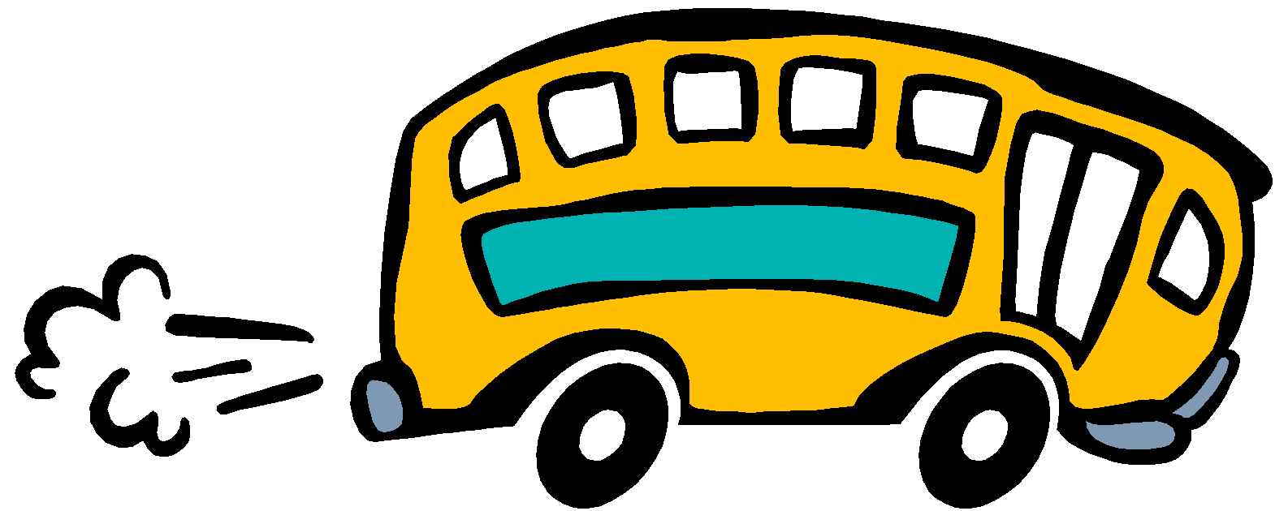

The teachers plan field trips as part of the instructional program. Notices are sent home in advance outlining the details and cost of the trip. No child may be taken on a field trip without written parental permission. Field trip permission must be done in writing rather than by phone.

All reservations are made in advance. Because we are obligated to pay for our reservations, we are not able to refund any money if your child misses the trip. Parents are often asked to help supervise field trips and, for the protection of our children, will be required to submit to a background check.

**Lost and Found**

If your child is missing an article of clothing, we suggest you check with us… it may be in our Lost and Found. To help avoid lost clothing, please label your children’s outer garments such as coats and sweaters. PLEASE label lunch boxes! Articles not claimed within a reasonable amount of time will be donated to a relief agency.

**Parent Teacher Association (P.T.A.)**

The P.T.A. is a valuable asset to the school. The members assist the school in many ways including planning events for students and their families, raising funds to purchase needed items and volunteering their time during the school year.

The P.T.A. meets periodically throughout the school year. Meeting dates are published in the school and P.T.A. newsletters. Parents, teachers and interested community members are encouraged to become members of the P.T.A. The success of the P.T.A. is dependent upon the active involvement and participation of all members of the Ridgeway family and community.

**Volunteers**

Volunteers are parents who contribute their time and talents toward the enrichment and support of our educational program. They may work with small groups of children or an individual child or help to prepare instructional materials (running off papers, laminating materials, etc.). There is an orientation held in late September (date to be announced). For more information, you may contact the Volunteer Coordinators or the school.

Please remember that volunteers may **not** bring preschoolers to accompany them during volunteer activities. This policy has been instituted for safety reasons.

**Behavior**



Students are expected to maintain proper standards of behavior at all times while at school. These standards include respect for the safety, property and rights of others, and as well as courteous treatment at all times. Please carefully note the Anne Arundel County Board of Education policies regarding student rights and responsibilities as stated in the *“Anne Arundel County Public Schools Parent/Student Handbooks.”*

Teachers will reward appropriate behaviors in a variety of ways, including distributing *Mustang Bucks, MMM Points*. Verbal reminders, think time, counseling and logical consequences are used to discourage inappropriate behavior. Parents will be notified of inappropriate behavior that occurs at school so that we can work together closely to modify and correct unacceptable conduct.

It is essential that parents reinforce our behavioral expectations at home. The staff and I will maintain close contact and open communication with families in order to ensure that every child has the chance to benefit from the instructional program in a safe, caring environment.



**Ridgeway Code of Conduct**

**Respect Myself**

Students will demonstrate respect for themselves by listening carefully, controlling personal behavior and completing all assignments to the best of their ability.

**Respect Others**

Students will demonstrate respect for others by working cooperatively, using positive language, showing empathy and treating others as they would like to be treated (no bullying).

**Respect Learning**

Students will demonstrate respect for learning by participating appropriately in class activities, staying focused on work and following all adult directions.

**Respect Property**

Students will demonstrate respect for our school by taking care of their classroom materials, keeping their classrooms neat and organized and using all school facilities appropriately.

**Behavior En Route to School**

Behavior before and after the bus arrives, or while walking to and from school, is a community responsibility that should be shared by all parents in a particular neighborhood. To alleviate problems, we suggest the following:

1. Do not send children on their walk or to the bus stop too early.
2. Parents, if possible, should accompany students to the bus stop or on their walk to school. Perhaps a schedule of days for different parents would be helpful.
3. If children are misbehaving, notify their parents.
4. If you have concerns about bus arrivals times or other bus concerns, please contact Ms. Carole Foley at 410-923-7884.

Cooperation from you, the community, will prevent the school from spending instructional time solving behavior problems that the children bring from the bus stop or walk to school.

**Transportation**

School bus transportation is a privilege. This privilege may be temporarily denied or permanently revoked if the misconduct of the child jeopardizes the safe operation of the school bus or the safety of pupils riding the bus. Parents are responsible for seeing that their child attends school despite the loss of riding privilege.

Please go over these bus regulations with your child.

1. Observe the same conduct as in the classroom.
2. Be courteous; use positive language.
3. Do not eat or drink on the bus.
4. Keep the bus clean.
5. Cooperate with the driver.
6. Do not be destructive.
7. Stay in your seat while the bus is in motion.
8. Keep your head, hands, feet and objects inside the bus.
9. Talk quietly to your friends.
10. Glass containers **are not** permitted on the bus.
11. Large instruments and/or projects that do not fit in a seat are not permitted.
12. Cell phones/electronics should not be used.

**Bicycle Riders**

Students riding bicycles to school must put them in the bicycle rack provided. Locks are strongly recommended.Bicycle riders **must walk** their bicycles on all school sidewalks. Scooters and Longboards must also be walked while on school property and must be parked in the bike rack. Scooters and Longboards are not permitted in the school building.

**Student Rights & Responsibilities**

A major goal of school systems in America is to prepare students for active, responsible participation in a democratic society. To develop an understanding and appreciation of our representative form of government, students need to participate in decision-making, exercise their rights and responsibilities as individuals, and educate themselves in the democratic process.

All students are given a booklet entitled “AACPS Student Handbook” which describes the programs, services and regulations of Anne Arundel County Public Schools annually. Within the booklet is a section entitled, *Student Rights and Responsibilities*, students and their families, should review this section carefully.

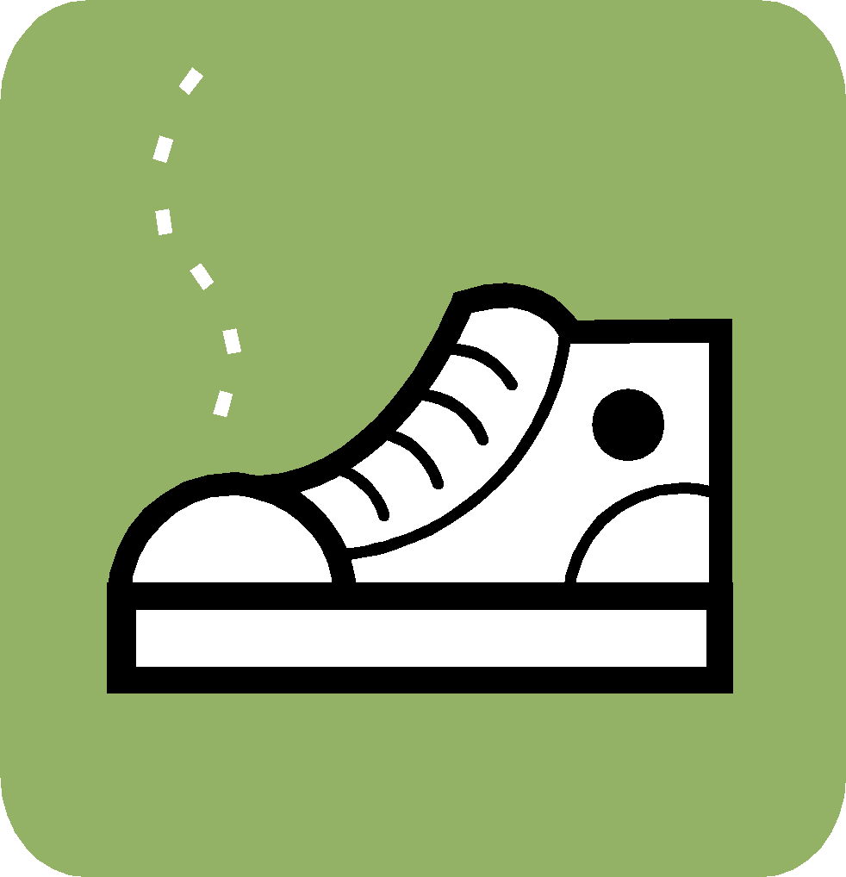



**AACPS Dress Code**

Ridgeway Elementary School follows the Anne Arundel County Public Schools dress code policy (JCD). Students have the right and responsibility to choose their attire and to arrange their personal appearance in a manner which is healthy, safe, inoffensive and not disruptive to the educational process. Accordingly, students are prohibited from wearing clothing, hats, jewelry, bookbags, or other articles of personal appearance which:

* Depict profanity, obscenity, violence, or symbols of hate
* Promote alcohol, drugs, tobacco or gang-related symbols
* Shows skin between the upper chest and mid-thigh

Shoes should enclose the foot. Due to safety concerns flip-flops are strongly discouraged.

**Weapons**

State law prohibits the carrying or possessing of certain weapons on public school property, and community expectations demand a firm stance against weapons in school.

In accordance with these principles, the Board strictly prohibits any student from possessing or using any weapon or dangerous implement on Board of Education property, including in school buildings or on school grounds; on school buses and other school vehicles; or during any school, school-related, or Board sponsored activity, whether held on school property or at locations off school property, including private clubs, businesses, or commercial establishments.

Any student who violates this policy shall face disciplinary action. Possession of a weapon or dangerous implement may result in suspension and/or expulsion. Use of a weapon or dangerous implement shall result in expulsion.

**Cell Phones/Smart Watches/Electronic Devices**

Students are not permitted to use cell phones or personal electronic devices while at school, on field trips and school buses or when attending a school sponsored event. Cell phones and electronic devices that are brought to school must be turned off and put away in backpacks.

For our students safety and privacy, photographs of students are not permitted during the school day unless for yearbook or instructional purposes. We ask that all visitors/volunteers needing to make a call on their cell phone do so in the main lobby or after exiting the building.

**Student Property**

Most students are assigned lockers for their belongings. Educational materials and supplies are kept in desks. Often several different children will sit in the same desk throughout the day, so it is a good policy to have your child label all of his/her belongings so that ownership may be easily determined. Students should understand that on occasion it might be necessary for school personnel to examine the contents of lockers or desks.

Students are not permitted to bring electronics, iPods, or toys to school unless they have a teacher’s permission to do so.

Students are issued materials for all basic needs of the instructional program. Minimal requests are made of parents for the purchase of supplementary materials. When teachers make these requests, it is because they feel the materials will enhance the effectiveness of the basic program.

Students are required to reimburse the school for textbooks, library books, Chromebooks, or materials that are not returned in good condition.