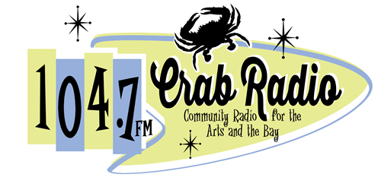

Did you know that in order to play songs on the radio, an agreement must be signed with various licensing organizations? There are three major organizations that handle the right to perform a composition (song) in public (and yes, that includes playing it on the radio, Internet or otherwise). Nearly all popular musicians are members of one of the big three: ASCAP, SESAC, and BMI. Crab Radio has an agreement with all of the “big three” and any song you can find on any of the lists is available for play on our station.

If a song is published before 1930, you do not need to worry about seeing if it is on the licensing site.

If the song is found on any ONE of the sites, then it is cleared to play on air.

**Navigating the Licensing Sites**

**ASCAP –** [**www.ascap.com**](http://www.ascap.com)

The top left of the site has a search option. Select the search bar and from the dropdown select “Search ACE Repertory.” You can search by title, writer, or publisher.

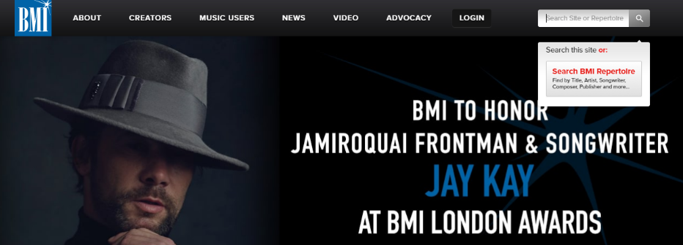**BMI –** [**www.bmi.com**](http://www.bmi.com)

The top right of the site has a search option. Hover over the search bar and select “Search BMI Repertoire.” Then you can search by title, writer, or  
publisher.

**SESAC –** [**www.sesac.com**](http://www.sesac.com)

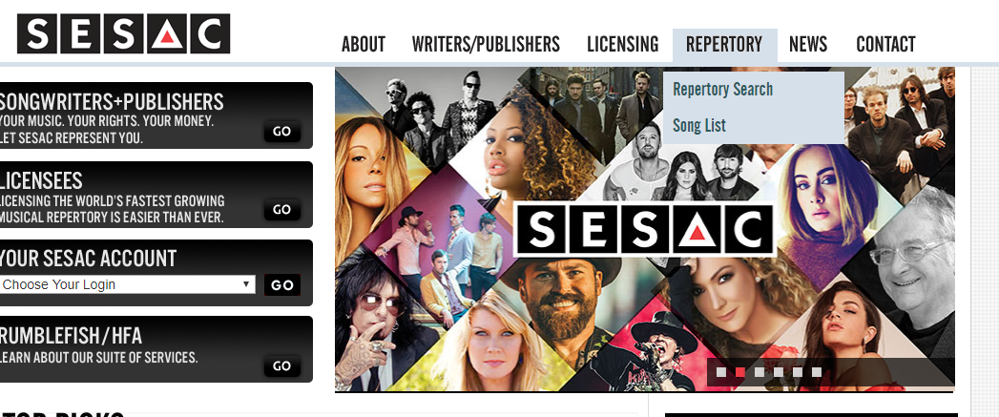

On the top toolbar, hover over the word REPERTORY. You are able to search through the entire repertory or by song title. You will have to agree to the terms of the agreement prior to searching.

**More information on the Licensing sites**

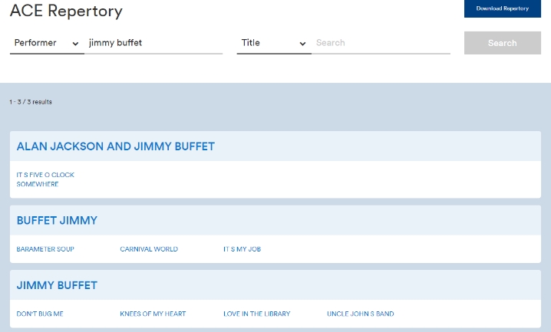**ASCAP**

If you type in the artist, all of the variations  
of the artist’s name will appear.

You can select each variation to search for  
the song you are trying to find. There are  
often more songs than the ones listed on the  
display, so make sure you check within the   
link.

You will notice that all of the songs that   
the artist has written or performed are   
listed.

When you select the song you want, just make sure that ASCAP, BMI, and/or SESAC is identified as PRO. If at least one of the organizations is identified, the song is approved for play on CrabRadio.

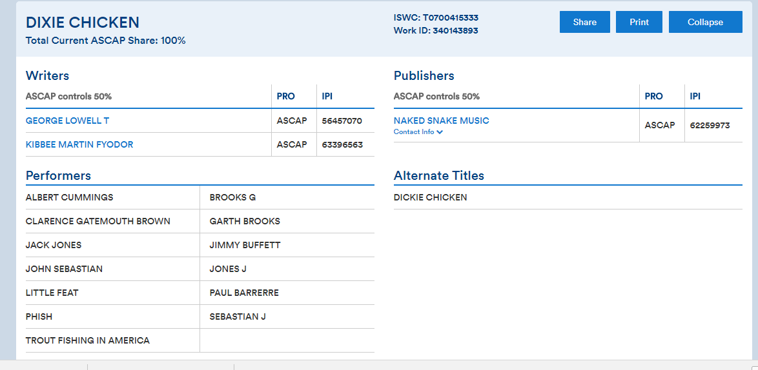

The song I was looking for was Dixie Chicken, by Jimmy Buffet. You can see here that it is listed on ASCAP and one of the approved performers of the song is Jimmy Buffet. This song is approved to play on CrabRadio.

**BMI**

Similar to the other searches, when you enter an artist’s name, all variations will be listed.

BMI’s site only identifies the song is listed with them.

In the screenshot below, you can see that only two songs sung by Katy Perry alone are listed. That means that only these two songs are approved for play.

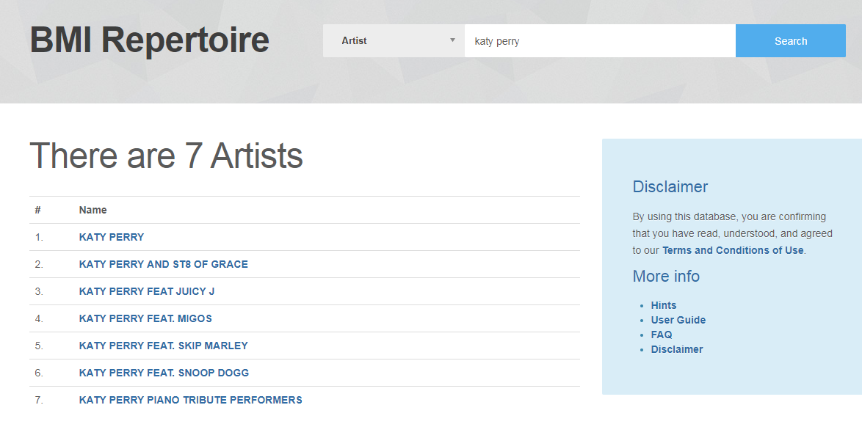

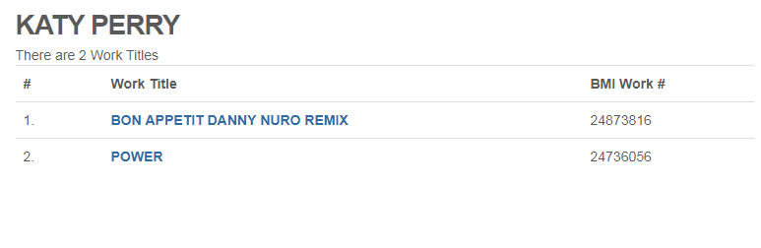

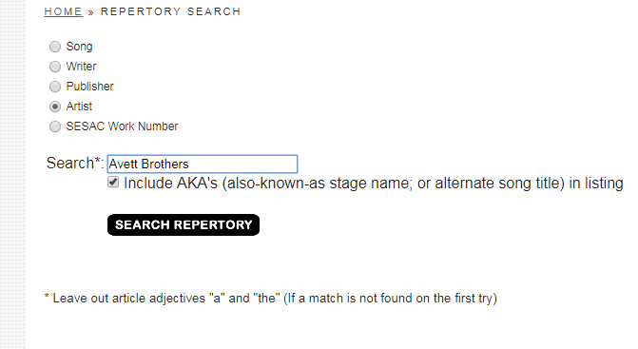**SESAC**

SESAC organizes its listings a little differently than the others. It provides a list of the songs and the associated album for the artist that was searched. If there is another variation on the name, then an additional list is also included after the initial search result.

If the song is on the list and comes from the associated album, then it is approved for play. I was looking for “Ain’t No Man” from the True Sadness album. It is there, so it is approved.

